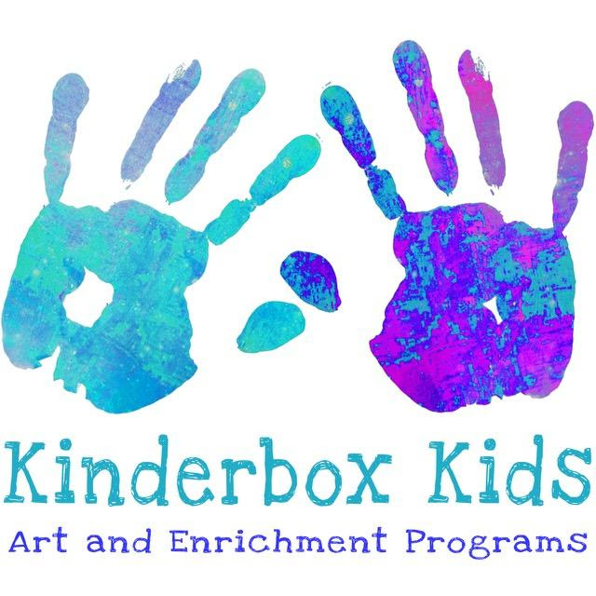

***Kinderbox Kids Art -ST GREGORY THE GREAT***

***Winter 2025 SESSION 2/5, 2/12, 2/26, 3/5, 3/12, 3/19, 3/26, 4/2***

***11:30 am to 12:10 pm  Fee $200***

***Payment cash or check***

***To register at Kinderboxkids.com click pod learning to complete the waiver***

***Email:*** ***Kinderboxgallery@gmail.com***

***This is a class for the child who loves to explore being creative in a friendly and encouraging atmosphere.  Children will explore mix media art through use of recycled materials, clay, articles of nature, sewing components and more.  Literacy and art, creative problem solving, creativity. self expression, sensory, threading, sorting,*** *counting****,*** *gluing****, cutting,*** *color and FUN!*

***ALL REGISTRTION FORMS MUST GO TO MS. JHERI***

***REGISTRATION FORM***

***CHILDS NAME________________________________________________AGE_______***

***Homeroom Teacher______________________________________________________***

***PARENTS NAME___________________________________________________________________***

***HOME PHONE__________________________________________________________________***

***CELL PHONE__________________________________Email____________________________***

***AUTHORIZED PICKUP PERSON___________________Phone #____________________***

***ANY ALLERGIES OR  MEDICAL CONDITIONS__________________________________***

***\*\*PLEASE HAVE CHILD IN PROPER CLOTHING OR BRING A SMOCK.***